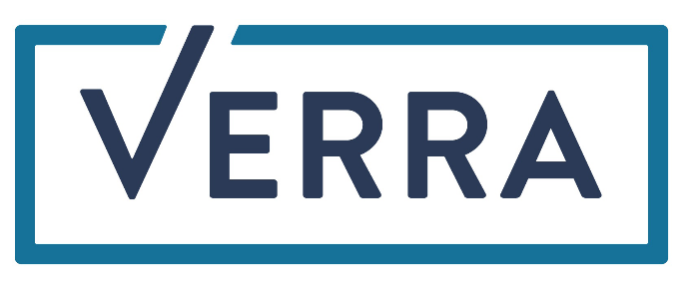

Verra certification Label
Proposal ForM
This template is for the submission of proposed certification labels for any Verra unit, required for any standards or programs developed by organizations different from Verra. The developer must submit the form electronically to Verra at info@verra.org.
Instructions for Completing the Proposal Form:

The proposal form must be completed using Arial or Franklin Gothic Book 10.5 point, black, regular (non-italic) font. All instructions, including this introductory page, should be deleted from the final document.
Instructions for completing the certification label proposal form are under the section headings in this template. Note that the instructions in this template are intended to serve as a guide and do not necessarily represent an exhaustive list of the information the developer should provide under each section of the template.

This form must be written in a clear and concise manner. Supporting information may be presented in appendices.

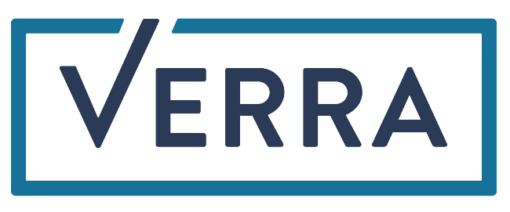

Label name | Proposed certification label name
Unit type to which the label would be applied | Specify whether the label is intended for Verified Carbon Units or another type of Verra unit e.g., Plastics credits or SD VISta assets
Submission date | DD-Month-YYYY this version of the form submitted
Proposed date of label implementation | Specify the proposed date when the labels would be ready to launch
Standard | Name of the organization submitting the form and proposing the new certification label
Prepared By | Individual or primary contact at entity that prepared the form
Contact | Physical address, telephone, email, website

eligibility criteria Demonstration
Please provide a response to each of the following eligibility criteria (attaching supporting documentation, as necessary), demonstrating the standard’s adherence to each:

- Please demonstrate and elaborate on the following: The standard administrator (e.g., the organization proposing the label) is a non-profit organization, government, or other regulatory body.
Response

- Please demonstrate and elaborate on the following: The standard administrator does not have any involvement in GHG project development that would represent a conflict of interest with respect to administering the standard.
Response

- Please demonstrate and elaborate on the following: The standard has been developed through a process of public stakeholder consultation or is the result of regulations that themselves have been developed and implemented through a process of public stakeholder consultation.
Response

- Please demonstrate and elaborate on the following: The standard is publicly available. Indicate where and how the standard can be publicly accessed.
Response

- Please demonstrate and elaborate on the following: The standard administrator maintains a public record of all projects that have been certified. Please specify the intervals at which records are regularly updated by the standard administrator.
Response

- Please demonstrate and elaborate on the following: The standard administrator issues a certification statement to the project that indicates compliance with the standard’s requirements, and the standard administrator uses consistent procedures for issuing certification statements and/or specifies such procedures for accredited entities to issue such statements. Where accredited entities may issue certification statements, the standard clearly specifies which accredited entities can issue such statements.
Response

- Please demonstrate and elaborate on the following: The standard is complementary to the objectives and scope of the Verra program to which the label will be applied. For example, a label to be applied to a VCU may provide certification with respect to a project’s social and environmental co-benefits.
Response

- Please demonstrate and elaborate on the following: The standard is applicable to project or program-level activities and to the emission reductions or removals or sustainable development benefits generated by such projects (e.g., it is not a certification that applies at the organizational level).
Response

certification procedure

Please attach an example certification statement to this application. In the box below, please detail the name(s) of the body(s) that will be issuing certification statements and how they are generated.

Please provide guidance on how Verra should ascertain the authenticity of certification statements provided by Project Proponents seeking label application, and any other requested review steps that Verra should take to confirm that the project is eligible for the label.

Please elaborate on any other requested characteristics of the proposed certification label, such as what constitutes an eligible VCU or whether labels may be applied retroactively.

certification level
 | Please indicate the level at which the standard administrator’s certification is granted.
☐ | Project level (i.e., granted once and indefinitely to a project)
☐ | Issuance level (i.e., must be renewed on a periodic basis and hence only pertains to a given vintage of VCUs)

If the standard administrator’s certification is granted at issuance level, please provide more information on how Verra can ascertain the time period of validity for the project’s certification to confirm that this period fully overlaps with the VCU vintage period(s) for which the label application is being requested (e.g. within the certification statement).
Response

Required documentation
The Verra Registry will need to determine whether a VCS project has attained the standard’s certification before labeling its VCUs. Please list below any specific documentation, including the certification statement, that will need to be submitted to the Registry as proof of a project’s attainment of the standard’s certification (add lines as necessary). Please attach examples of each required document in addition to the example certification statement.

Document Name | Description of Document

representation

I represent and warrant to Verra that the information provided herein is true and correct, to the best of my knowledge.
I understand and acknowledge that if the information provided herein is amended or is no longer accurate, I will immediately notify Verra of such changes.

Name of duly Authorized Representative:
Title:
Organization:
Date:
Signature:

Inter

For information on the difference between market and certification labels, or the application form for market labels, please see the Verra website.

