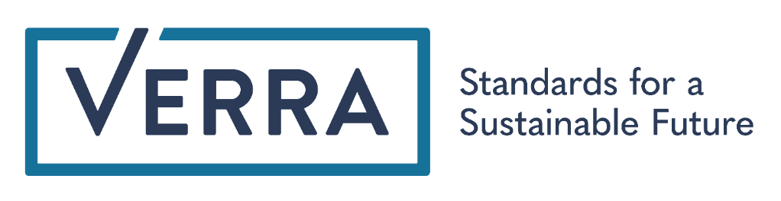

Sustainable Development Contributions Report Template
This template is for the self-reporting of a project’s contribution(s) to specific Target(s) of the Sustainable Development Goals (SDGs). The SDG Targets represent the default sustainable development criteria against which projects report.
This template is not for reporting a project’s verified contributions to the SDGs. Projects that wish to report verified contributions to the SDGs and label VCUs with specific sustainable development contributions must undergo verification through the Sustainable Development Verified Impact Standard (SD VISta) Program.

Instructions for Completing the Sustainable Development Contributions Report
TITLE PAGE: Complete all items in the boxes on the title page using Arial or Century Gothic 10.5 point, black, regular (non-italic) font. All boxes must appear in the final document. Reports may also feature the title and preparers’ name, logo and contact information more prominently on the title page, using Arial or Century Gothic 24 point font for title and Arial or Century Gothic 12 point, black font for all other information.
SUSTAINBLE DEVELOPMENT CONTRIBUTIONS REPORT: Instructions for completing the sustainable development contributions report template are given under the section headings in this template. All instructions must be followed.
Complete all sections using Arial or Franklin Gothic Book 10.5pt, black, regular (non-italic) font. Where a section is not applicable, same must be stated under the section (the section must not be deleted from the final document).
All instructions, including this introductory text, should be deleted from the final document.

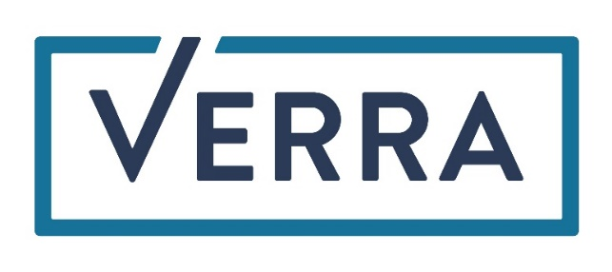

Project TITLE
Logo (optional)
Document Prepared By (individual or entity)
Contact Information (optional)

Project Title | Name of project
Project ID | Verra project ID number
Project Start Date | DD-MON-20XX of the Verra project start date
SD Contributions Reporting Period | DD-Month-20YY to DD-Month-20YY during which the project contributed to the default sustainable development criteria (i.e., to the SDG Targets)
Date of Issue | DD-MON-20XX this version of the report issued
Prepared By | Individual or entity that prepared this document
Contact | Physical address, telephone, email, website

SUMMARY of sustainable development CONTRIBUTIONS
Provide a brief description that includes the following (no more than 100 words):
- A summary description of project activities (i.e., technologies/measures implemented, project location).
- An explanation of how project activities will result in the sustainable development (SD) contributions described in Section 2 of this report.
Examples of this summary are provided in Appendix 2 below.
Evidence of the project’s SD contributions shall be provided as separate attachments, as appendices to this report, or in Verra project documents. Use Appendix 1 below to provide evidence or indicate in which documents evidence may be found.

Project Contributions
Using Table 1 below, provide the project’s quantifiable contributions to specific targets and indicators of the Sustainable Development Goals (SDGs) for the SD contributions reporting period. Use the official list of SDG Targets and Indicators (available here) to identify the SDG Targets to which the project has contributed. Evidence for each contribution shall be identified in Appendix 1 below.
Contributions should be aligned with the SDGs, as follows:
- Where possible, relate all contributions to official SDG targets and indicators. Refer to the SDG metadata repository (available here) for guidance on the definitions and concepts included in the SDG indicators (see the examples in rows 1 and 2 in the table below).
- While climate change and mitigation activities relate to SDG 13, they do not align with any SDG 13 target. For climate change mitigation impacts, write “13.0” in the SDG target column and use the indicator “Tonnes of greenhouse gas emissions avoided or removed” (see the example in row 3 in the table below).
- Where a project’s self-defined measure for tracking a benefit does not align with an official SDG indicator, do not provide an indicator number. Instead, write a project-specific indicator that relates to the most appropriate SDG target (see the example in row 4 in the table below).
Document total project contributions since the project start date or previous SDG contribution reporting period in the “Current Project Contributions” column below and the cumulative contributions over the project lifetime in the “Contributions Over the Project Lifetime” column in Table 1 below.
Remove rows 1-4 of Table 1 below, which serve as instruction and examples. Add or remove other rows from the table as necessary.

Table 1 : Sustainable Development Contributions
Row number | SDG Target | SDG Indicator | Net Impact on SDG Indicator | Current Project Contributions | Contributions Over Project Lifetime
Sequential row number | SDG Target number | Number and text of SDG indicator or, if no official SDG indicator is applicable, user-defined indicator | Indicate the project’s contribution to the SDG Indicator (implemented activities to increase or decrease) | Brief description of the quantifiable impact of the project’s activities related to the SDG indicator, during the project SDG contributions reporting period. | Brief description of the cumulative quantifiable impact of the project’s activities related to the SDG indicator, over the project lifetime.
1) | 1.1 | 1.1.1 Proportion of population below the international poverty line | Implemented activities to decrease | No further changes this reporting period | The project has increased the 65 participants’ total daily income from 1.20 USD/day to 2.57 USD/day, bringing them above the international poverty line
2) | 3.2 | 3.2.1 Under 5 mortality rate | Implemented activities to decrease | Four community health clinic workshops held to provide education and training on antenatal/postnatal care for 60 women from four villages | Provided education and training on antenatal/postnatal care for 300 women
3) | 13.0 | Tonnes of greenhouse gas emissions avoided or removed | Implemented activities to increase | By conserving 400 ha of tropical rainforest, Project X has prevented the release of 250 thousand tonnes of carbon into the atmosphere during the reporting period | Prevented the release of 750 thousand tonnes of carbon into the atmosphere
4) | 6.1 | Proportion of the rural population who have easy access to a safe water supply | Implemented activities to increase | Completed construction of 4 additional improved wells to provide potable water to 230 people | Provided at least 10 liters of potable water per day to 1,200 people, a 40% increase in the catchment area, over the project lifetime by constructing improved wells

Appendix 1: Supporting Evidence
Provide evidence for each contribution listed in Table 1. Evidence may be provided directly here or through publicly accessible referenced documents, such as VCS project documents. If evidence is provided through referenced documents, briefly summarize the evidence here along with a hyperlink to the supporting evidence.

Appendix 2: example SUMMARIES of Sustainable Development ACTIVITIES

[Delete this appendix from final version of report]

Example 1
In XYZ Region of XYZ Country, NGO A is facilitating shade tree planting by small groups of community members to increase the long-term productivity of their cacao forest and sequester carbon. The shade trees also provide edible fruits and nuts, medicines, firewood, timber, windbreaks and soil stabilization. Project participants earn increased income from cacao sales and new income from the sale of VCUs.
Participants in this project exchange lessons about biodiversity and climate change. They are provided with access to mobile banking. The project also offers local leadership opportunities and training in tree measurement, GPS technology and data entry skills.

Example 2
Company B’s 40 wind turbines are located in XYZ City, north-western XYZ Country. Electricity generated by the project is fed into the regional electricity grid, displacing energy that would otherwise be generated by fossil fuels.
As part of regional development efforts associated with the wind project, Company B constructed a health clinic and paid for one administrative staff and one medical staff member focused on women and children’s health to be in attendance two days a week. The project also provides free electricity to four schools in the region.

Example 3
This run-of-river hydropower plant located in XYZ Area, XYZ Jurisdiction, XYZ Country, adds an average of 80 GWh of power to the grid every year, replacing fossil fuel powered electricity. Company C, which built the hydropower plant, also built out the grid to extend power to rural villages and electrify schools.

Example 4
The construction and operation of an electric mass transit system in XYZ City, XYZ Country provides its ### daily users with enhanced quality of life due to reduced travel time, less congestion and fewer accidents as compared with their previous commutes. Compared with the fossil fuel powered transport systems it replaced (cars, minibuses and buses), the new system generates less particulate matter and GHG emissions. Semi-skilled, skilled and professional job opportunities were created by the construction and operation of the electric transit system.

